**Day 4 Lab Coding Challenges**

In this Lab,

Scenario is that, you are part of an IT Divisions UX team and the Team wants you to create a Catalog to showcase few features of the BootStrap, which can be used to explain the clients about the look and feel of some of the features of BootStrap (ready made components) from which the client can choose their required BootStrap features

(Since this is just an exercise, we are not featuring all features of BootStrap but a few)

You can use a Frameset as shown below:

**Hint : MainFramePage.html is the opening page from where all pages open up**

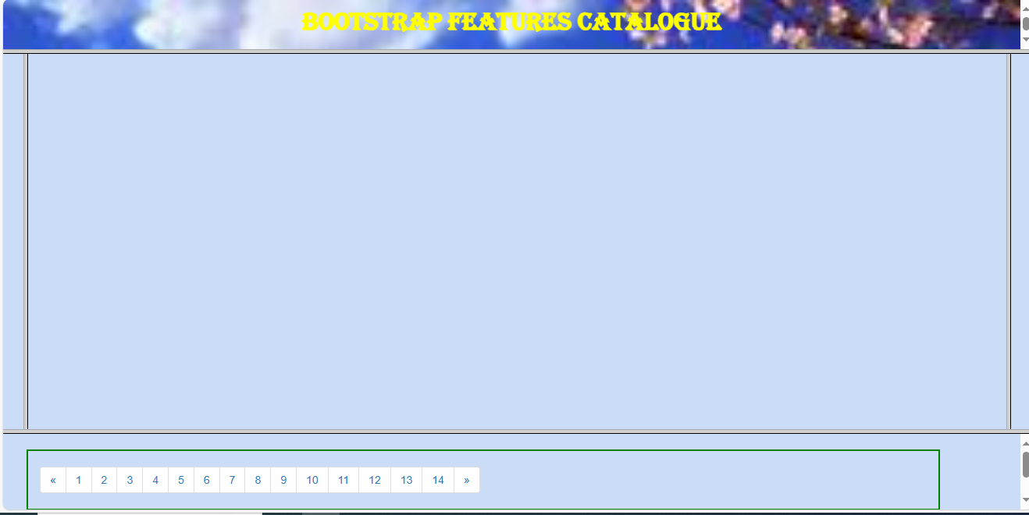

The center(middle) frame is the contents frame and the bottom most frame should contain the Pagination control and the respective pages in the Pagination control , should project the corresponding Bootstrap feature’s sample implementation in the “Contents” frame.

The Features that are to be Projected are as follows:

1. Jumbotron, ButtonTypes & Button Groups & Glyphicon based Buttons
2. Jumbotron with Contextual Colored Text with & without image , Contextual BG Colored text
3. Input Group Types
4. Menu Types & NavBar
5. Pagination , Thumbnails & ProgressBar
6. Media control with images
7. FormGroup
8. FormGroup
9. FileInput
10. FormGroup - radios & Checkbox
11. Form Controls
12. Collapsible Columns
13. Well Object
14. Carousel

Few of the Snapshots for the corresponding pages of Pagination control are as follows:

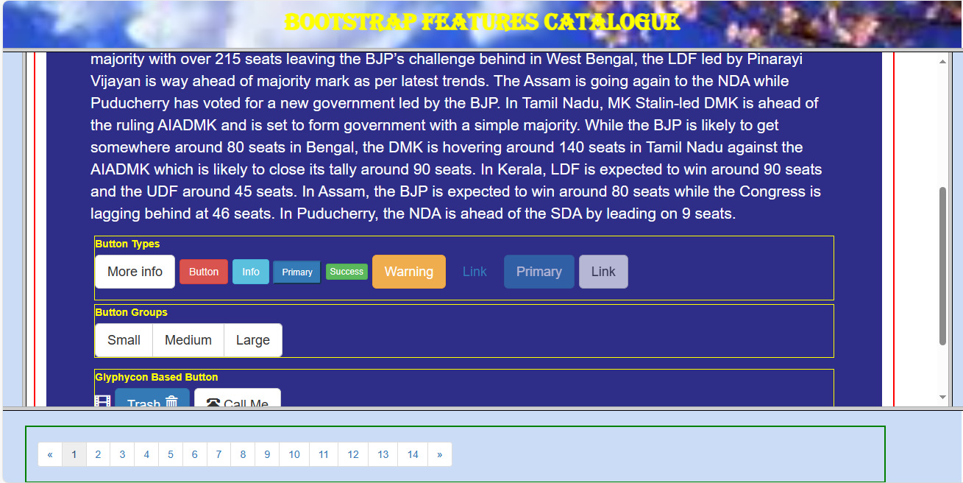

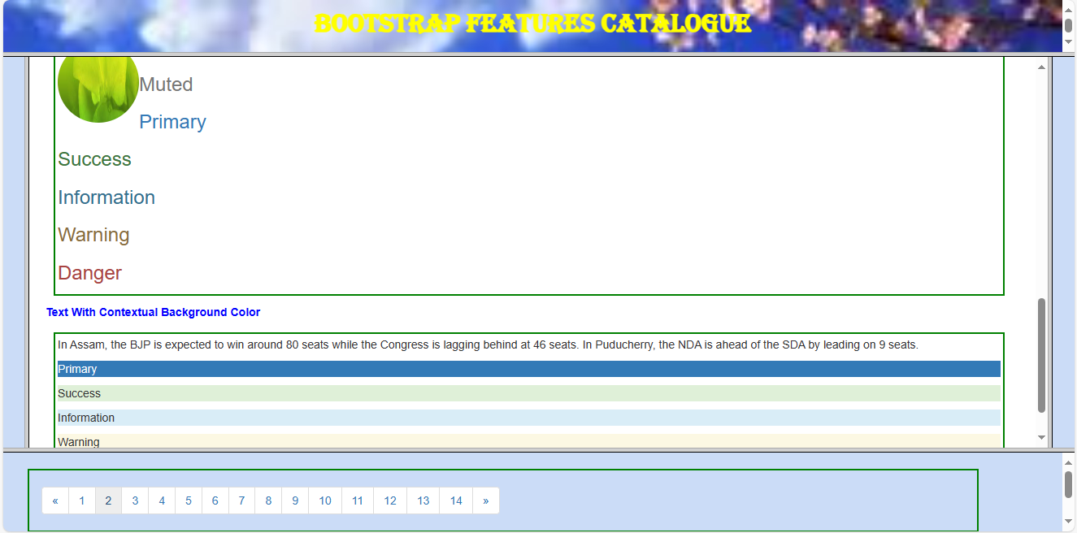

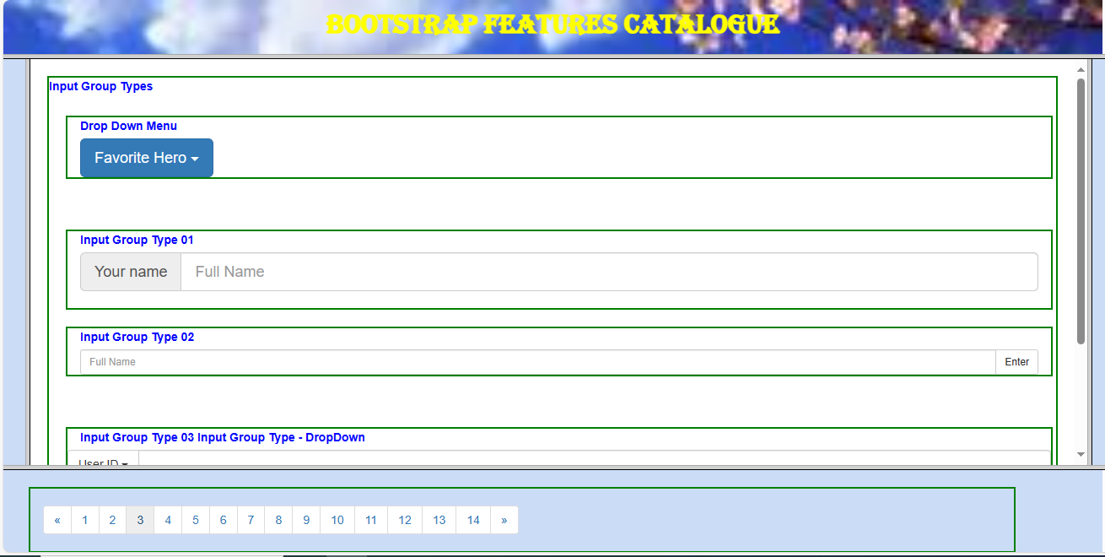

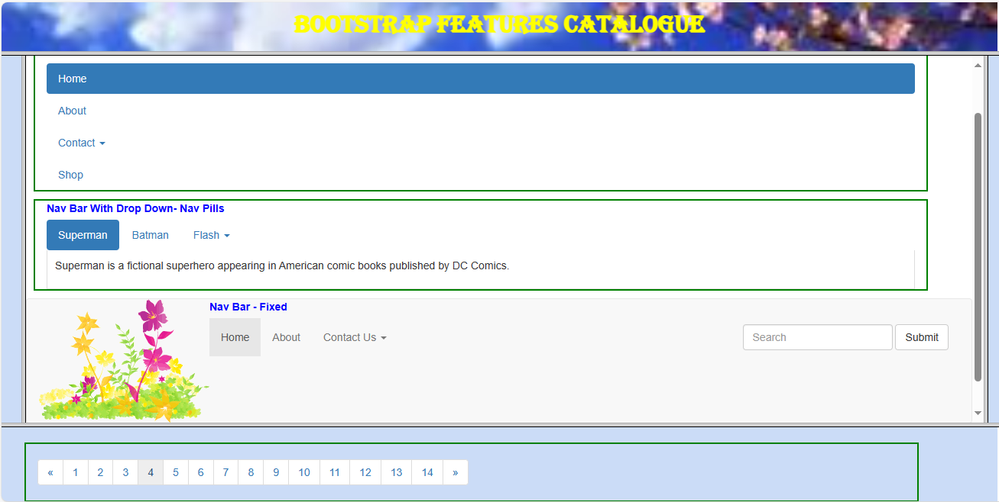

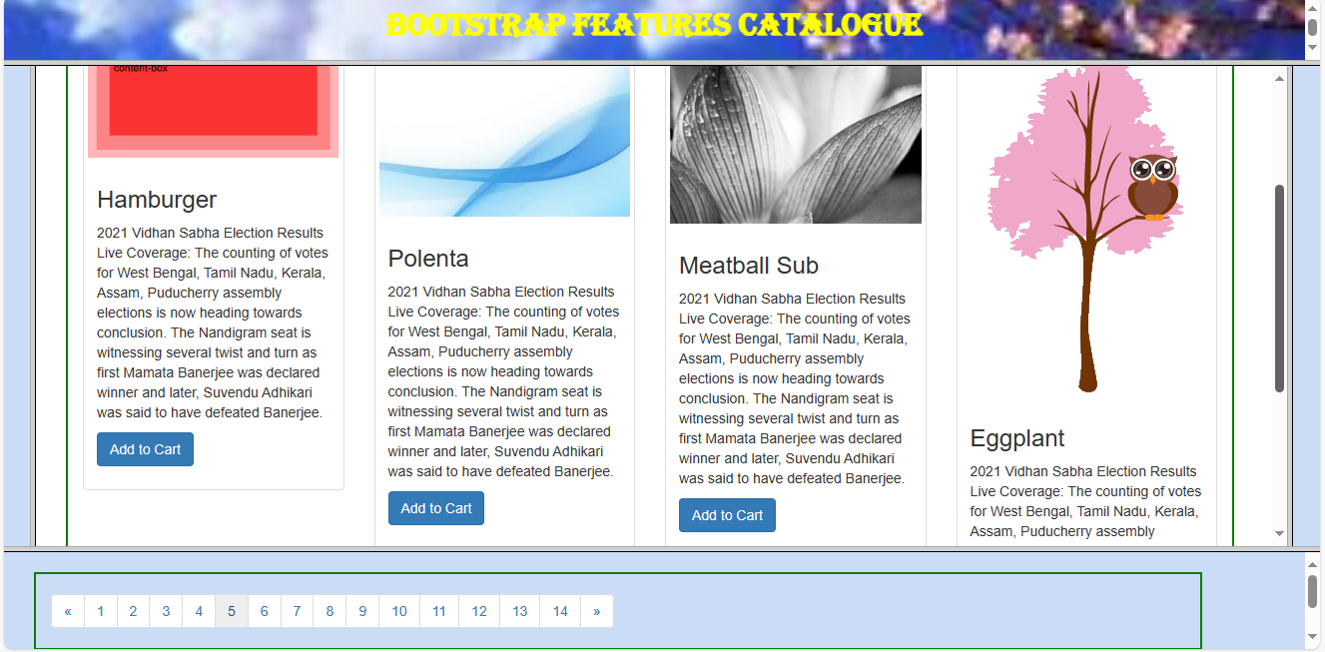

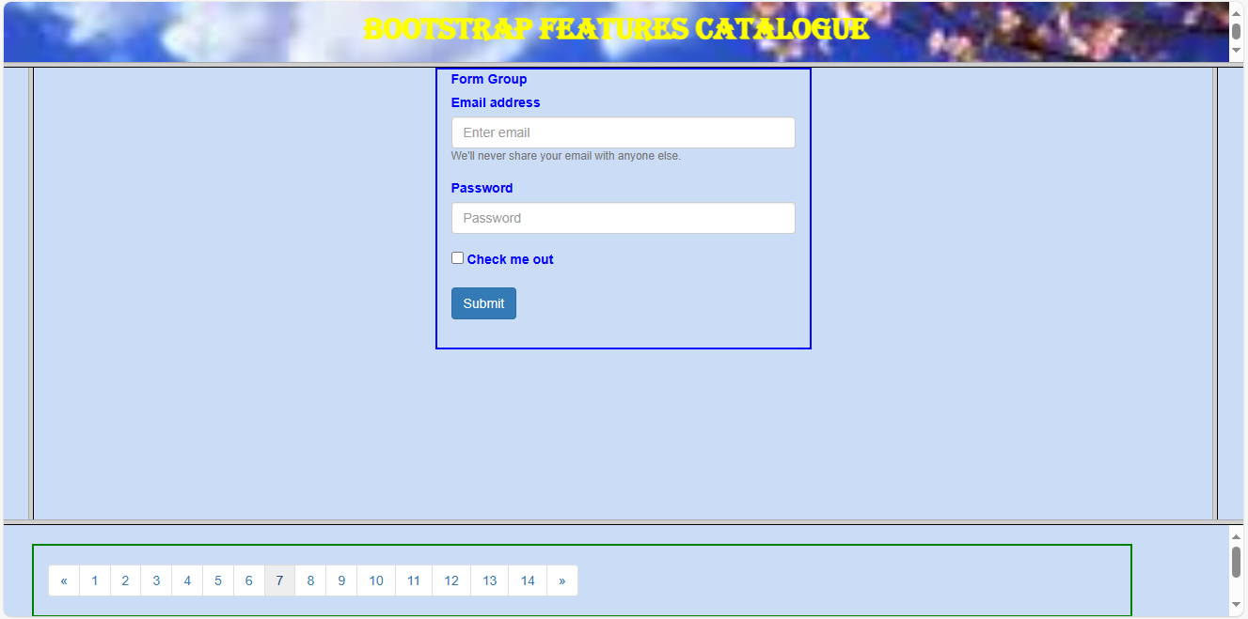

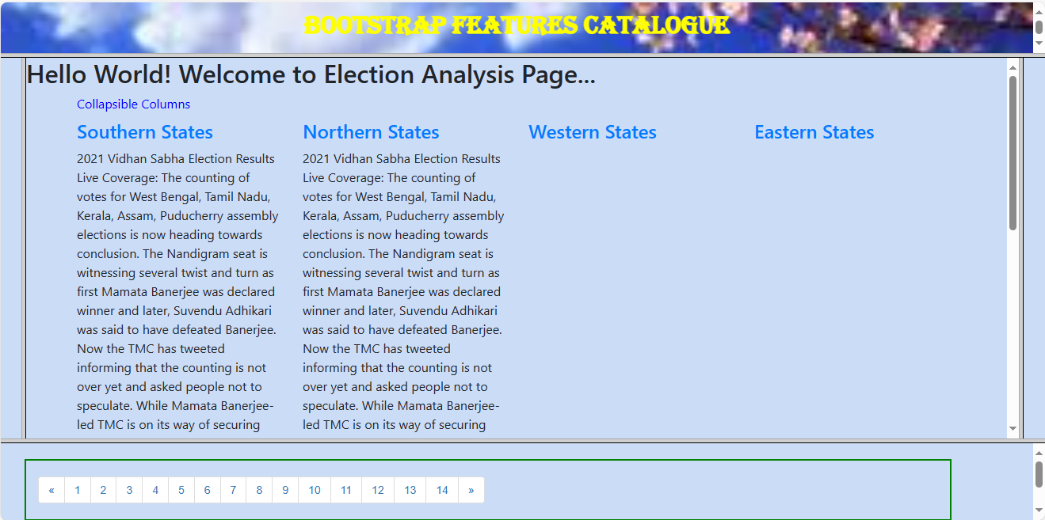

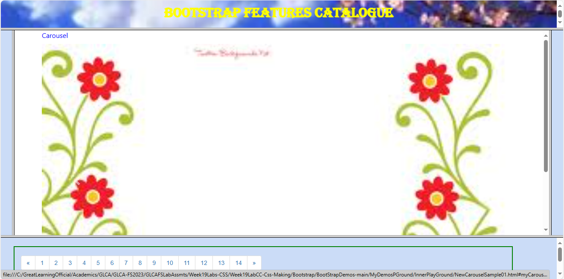

—------------------------------------------------------EOD—------------------------------------------------------------